“Celebrating the Sonoran Desert”
2021 Sonoran Shindig Photo Show
In the Plaza March 6th – 31st 2021
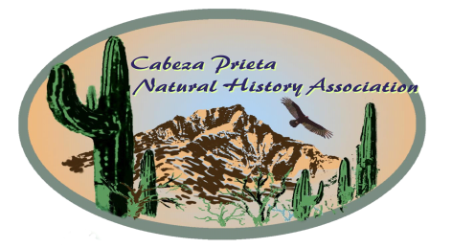
Entry Form Print, very neatly, please.

Photos must be taken only in the Sonoran Desert.

* By entering this photo, I grant Cabeza Prieta Natural History Assoc. (CPNHA) use of it for their exhibit, website and other media. If asked I will provide a digital copy.
Print Name__________________________

_______________________________________________
Signature Date
Parent/guardian signature if entrant is a minor
___________________________________________

Please read and follow all rules.
Please complete BOTH sides of this form.

ENTRY DEADLINE: Wed Mar 3rd 3 pm
Hand-deliver your entry to:
Ajo Chamber of Commerce Ajo Plaza
Or mail to CPNHA PO Box 234, Ajo, AZ 85321

Neatly print your name and photo title on the lines below. Mount this form on the back of the photo. Align bottom of photo with *** so your name and title are visible at the lower right- hand corner of the photo when viewed from the front.
If they aren’t, please adjust the form Questions? Contact Show Chair Paul 406-465-6029
******** align bottom of photo on these asterisks *******

Title______________________________________

Name__________________________________________

(Lift for contact info)
If photo is for sale Phere____. Price $_____

SHOW RULES Photos must highlight an aspect of the Sonoran Desert, showcase special features, or make a statement enabling viewers to make personal connec- tions with the Sonoran Desert. Titles matter!

Photo format- rectangle or square. Minimum 8x10, up to a maximum of 16x20. Color or black and white. Mounted on foam board. Trimmed to photo size.
No mats, frames, borders or vignettes.

Photo format- rectangle or square. Minimum 8x10”, to a maximum of 16x20”. Color or black and white. Mounted on foam board. Trimmed to photo size.
No mats, frames, borders or vignettes.

Personal identification, copyright marks, text or dates
may not be on the photo iteslf.

*All photos will remain on display until March 31st.
Photo pick up at the Gallery on March 31st...
Or **Claim photos at the Ajo Chamber by one week after close of show. Or contact the show chair re mailing or holding them for you till next season.

*Unclaimed photos become property of CPNHA.
*No limit to entries per category.
*Photos may be sold but must remain until end of show.
*Photos from prior CPNHA exhibits are ineligible.
*CNPHA reserves the right to disqualify an entry.
*Checkmark a category below that fits this photo, otherwise the exhibit committee will assign one.

____People in the Desert - must include a person in the picture or evidence of people.

____Desert Places - an old corral, a rock bench. Or?

____Desert Landscapes - vistas, sunsets, etc.

____Desert Plants - wildflowers, cacti, grasses, trees-dead or alive… and others of this ilk.

____Desert Animals - desert critters - birds, bugs,
other beasts or traces of them, i.e. webs, bones etc.
tracks, whatever pattern catches your eye.

Yes, this box is upside down on purpose
. Web Site Entry Form
Special instructions:
.
. Print one entry form for each
. photo you plan to enter in the
. exhibit.
.
. Fill in both columns with all
. requested information.
.
. Cut this instruction column off
. along the dotted line.
.
. Fold the remaining piece with
. the completed information in
. half vertically (length-wise) so
. the two columns are back to
. back with the printing on the
. outside.
.
. Follow the directions at the
. bottom of the first column to
. attach the entry form to
. the photo. Your name and
. the title must be visible at the
. lower right corner when seen . from the front.
.
.

