“Celebrating the Sonoran Desert”
2017 Sonoran Shindig Photo Exhibit
In the Plaza March 13-31st, 2017 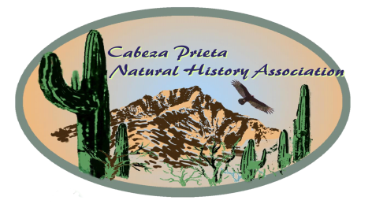
Entry Form Print, very neatly, please.

Photo Site or Area_________________________
Photos must be taken only in the Sonoran Desert.

* By entering this photo, I grant Cabeza Prieta Natural History Assoc. (CPNHA) use of it for their exhibit, website and other media. If requested, I will provide a digital copy. Please read and follow all rules. Please sign below and complete both sides of this form.

Name_(print)_________________________

___________________________________________
Signature Date

ENTRY DEADLINE: Sat Mar 11th 12 noon
Hand-deliver your entry to:
Ajo Chamber of Commerce Ajo Plaza
Or mail to CPNHA PO Box 234, Ajo, AZ 85321

Neatly print your name and photo title on the lines below. Mount this form on the back of the photo. Align bottom of photo with *** so your name and title are visible at the lower right- hand corner of the photo when viewed from the front.
If they aren’t, please adjust the form.
Questions? 602-321-9042 or alaskalani@gmail.com
******** align bottom of photo on these asterisks *******

Name_________________________________

Title
Contact:_Email_____________________________

Phone (talk or text) __________________________

PHOTO SHOW RULES

**Photo sizes- no smaller than 8x10 nor larger than 16x20. Color or black and white. Mounted on foam board trimmed to photo size. No mats, frames or
vignettes.

*All winning photos will remain on display until Fri. March 31st

*No personal identification, text or dates may be on the photo itself when viewed from the front.

*Photos may be claimed at exhibit AFTER Shindig closing or at the Ajo Chamber BY Mar. 31^{st.} Winners will be contacted concerning return of their photos

*Unclaimed photos become property of CPNHA.

*No more than 3 entries per category.

*Photos from prior CPNHA exhibits are ineligible.

*CNPHA reserves the right to disqualify an entry.

*Checkmark a category below that fits this photo, otherwise the exhibit committee will assign one.

____People in the Desert - must include a person in the picture or evidence of people.

____Desert Places - an old corral, a rock bench. Or?

____Desert Landscapes - vistas, sunsets, etc.

____Desert Plants - wildflowers, cacti, grasses, trees-dead or alive… and others of this ilk.

____Desert Animals - desert critters - birds, bugs,
other beasts or traces of them, i.e. webs, bones etc.

____Desert Patterns - shadows, ripples, tree bark, lizard tracks, whatever pattern catches your eye.

. Web Site Entry Form
. Special instructions:
.
. Print one entry form for each
. photo you plan to enter in the
. exhibit.
.
. Fill in both columns with all
. requested information.
.
. Cut this instruction column off
. along the dotted line.
.
. Fold the remaining piece with
. the completed information in
. half vertically (length-wise) so
. the two columns are back to
. back with the printing on the
. outside.
.
. Follow the directions at the
. bottom of the first column to
. attach the entry form to
. the photo. Your name and
. the title must be visible at the
. lower right corner when seen . from the front.
.
. The show committee will
. put an entry ID # in
. the box by your name.

